Example 1: Find the displacement, average velocity, and average speed of the car in Figure given below between positions A and B.
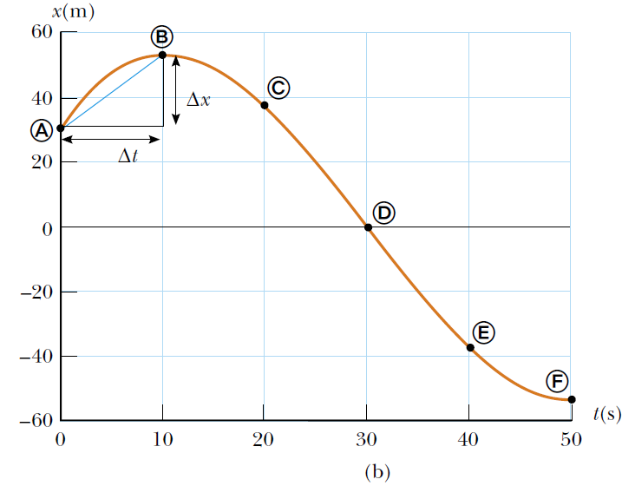

Example 2: A particle moves along the x axis. Its position varies with time according to the expression $x=2t^{2}-4t$where x is in meters and t is in seconds. Note that the particle moves in the negative x direction for the first second of motion, is momentarily at rest at the moment t=1 s, and moves in the positive x direction at times t> 1 s. (A) Determine the displacement of the particle in the time intervals t= 0 to t=1s and t =1 s to t=3 s. (B) Calculate the average velocity of the during there time position graph. (C) Find the instantaneous velocity of the particle at t=2.5s

Example 3: The position of an object moving along the x axis varies with time as in Figure given below. Graph the velocity versus time and the acceleration versus time for the object.
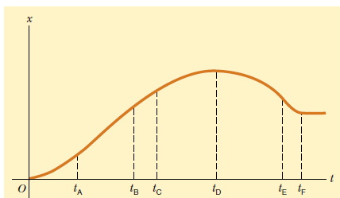

Example 4: The velocity of a particle moving along the x axis varies in time according to expression $v_{x}=\frac{\left(40-5t^{2}\right)m}{s}$ where t is in second. (A) Find the average acceleration in the time interval t=0 to t=2s. (B) Determine the acceleration at t=2s.

Example 5: A tennis ball is dropped from shoulder height (about 1.5 m) and bounces three times before it is caught. Sketch graphs of its position, velocity, and acceleration as functions of time, with the +y direction defined as upward.

Example 6: A stone thrown from the top of a building is given an initial velocity of 20.0 m/s straight upward. The building is 50.0 m high, and the stone just misses the edge of the roof on its
way down, as shown in Figure. Using $t_{A}=0$ as the time the stone leaves the thrower’s hand at position A, determine (A) the time at which the stone reaches its maximum height, (B) the maximum height, (C) the time at which the stone returns to the height from which it was thrown,
(D) the velocity of the stone at this instant, and (E) the velocity and position of the stone at t= 5s.
