PROBLEMS
Example-1 (P1): A force F applied to an object of mass m₁ produces an acceleration of 3.00 m/s². The same force applied to a second object of mass m₂ produces an acceleration of 1.00 m/s². (a) What is the value of the ratio m₁/m₂? (b) If m₁ and m₂ are combined, find their acceleration under the action of the force F.
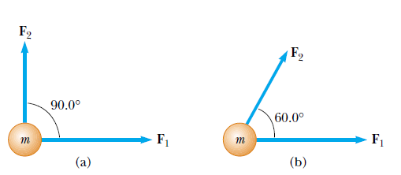
Example-2(P11): A Two forces F₁ and F₂ act on a 5.00-kg object. If F₁ =20.0 N and F2 =15.0 N, find the accelerations in (a) and (b) of Figure

Example-3(P14): Three forces acting on an object are given by F₁= (-2.00ˆi+ 2.00ˆj ) N, F2 =(5.00ˆi -3.00ˆj) N, and F3 =(-45.0ˆi) N. The object experiences an acceleration of magnitude 3.75 m/s². (a) What is the direction of the acceleration? (b) What is the mass of the object? (c) If the object is initially at rest, what is its speed after 10.0 s? (d) What are the velocity components of the object after 10.0 s?
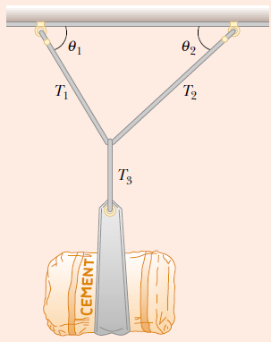
Example-4(P18): A bag of cement of weight 325 N hangs from three wires as suggested in Figure. Two of the wires make angles ʘ₁= 60.0° and ʘ₂=25.0° with the horizontal. If the system is in equilibrium, find the tensions T1, T2, and T3 in the wires.

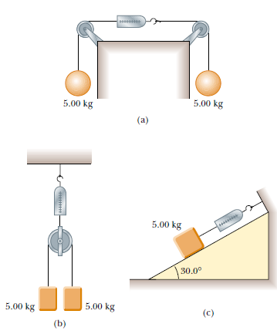
Example-5(P21): The systems shown in Figure are in equilibrium. If the spring scales are calibrated in Newton, what do they read? (Neglect the masses of the pulleys and strings, and assume the incline in part (c) is frictionless.)

Example-6(P17): The distance between two telephone poles is 50.0 m. When a 1.00-kg bird lands on the telephone wire midway between the poles, the wire sags 0.200 m. Draw a free-body diagram of the bird. How much tension does the bird produce in the wire? Ignore the weight of the wire.
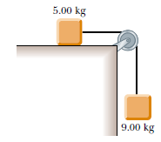
Example-7(P24): A 5.00-kg object placed on a frictionless, horizontal table is connected to a string that passes over a pulley and then is fastened to a hanging 9.00-kg object, as in Figure. Draw free-body diagrams of both objects. Find the acceleration of the two objects and the tension in the string.
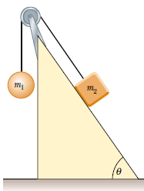
Example-8(P26): Two objects are connected by a light string that passes over a frictionless pulley, as in Figure. Draw free-body diagrams of both objects. If the incline is frictionless and if m1 = 2.00 kg, m2= 6.00 kg, and ʘ=55.0°, find (a) the accelerations of the objects, (b) the tension in the string, and (c) the speed of each object 2.00 s after being released from rest.
Example-9(P36): A 25.0-kg block is initially at rest on a horizontal surface. A horizontal force of 75.0 N is required to set the block in motion. After it is in motion, a horizontal force of 60.0 N is required to keep the block moving with constant speed. Find the coefficients of static and kinetic friction from this information.

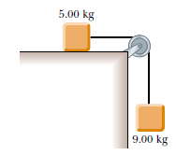
Example-10(P43): A 9.00-kg hanging weight is connected by a string over a pulley to a 5.00-kg block that is sliding on a flat table (Fig.P5.24). If the coefficient of kinetic friction is 0.200, find the tension in the string.

