PROBLEMS-7

Example-1: When a particle rotates in a circle, a force acts on it directed toward the center of rotation. Why is it that this force does no work on the particle?
Example-2: A shopper in a supermarket pushes a cart with a force of 35.0 N directed at an angle of 25.0° downward from the horizontal. Find the work done by the shopper on the cart as he moves down an aisle 50.0 m long.

Example-3 :. A raindrop of mass 3.35 10⁻⁵ kg falls vertically at constant speed under the influence of gravity and air resistance. Model the drop as a particle. As it falls 100 m, what is the work done on the raindrop (a) by the gravitational force and (b) by air resistance?

Example-4 : For any two vectors A and B, show that $A∙B=A_{x}B_{x}+A_{y}B_{y}+A_{z}B_{z}$

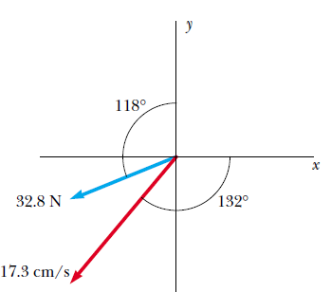
Example-5 : Find the scalar product of the vectors in Figure

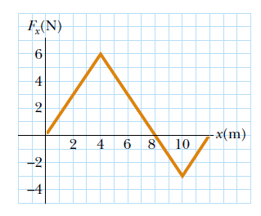
Example-6 : The force acting on a particle varies as in Figure. Find the work done by the force on the particle as it moves (a) from x=0 to x= 8.00 m, (b) from x=8.00 m to x=10.0 m, and (c) from x=0 to x = 10.0 m.

:
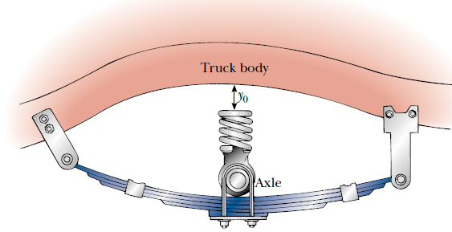
Example-7 : Truck suspensions often have “helper springs” that engage at high loads. One such arrangement is a leaf spring with a helper coil spring mounted on the axle, as in Figure. The helper spring engages when the main leaf spring is compressed by distance y₀, and then helps to support any additional load. Consider a leaf spring constant of 5.25 10⁵ N/m, helper spring constant of 3.60 10⁵ N/m, and y₀ = 0.500 m. (a) What is the compression of the leaf spring for a load of 5.00 10⁵ N? (b) How much work is done in compressing the springs?

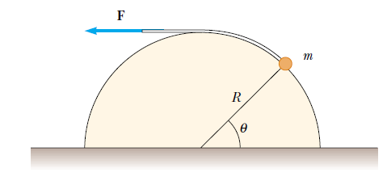
Example-8 : A small particle of mass m is pulled to the top of a frictionless half-cylinder (of radius R) by a cord that passes over the top of the cylinder, as illustrated in Figure. (a) If the particle moves at a constant speed, show that F= mg cos(ʘ) (Note: If the particle moves at constant speed, the component of its acceleration tangent to the cylinder must be zero at all times.) (b) By directly integrating, find the work done in moving the particle at constant speed from the bottom to the top of the half-cylinder.

Example-9: A 3.00-kg object has a velocity (6$\hat{i}$ - 2$\hat{j}$) m/s. (a) What is its kinetic energy at this time? (b) Find the total work done on the object if its velocity changes to (8$\hat{i}$ + 4$\hat{j}$)m/s. (Note: From the definition of the dot product, $v^{2}=v∙v$)

Example-10 : A 2.00-kg block is attached to a spring of force constant 500 N/m. The block is pulled 5.00 cm to the right of equilibrium and released from rest. Find the speed of the block as it passes through equilibrium if (a) the horizontal surface is frictionless and (b) the coefficient of friction between block and surface is 0.350.

Example-11: A 650-kg elevator starts from rest. It moves upward for 3.00 s with constant acceleration until it reaches its cruising speed of 1.75 m/s. (a) What is the average power of the elevator motor during this period? (b) How does this power compare with the motor power when the elevator moves at its cruising speed?

